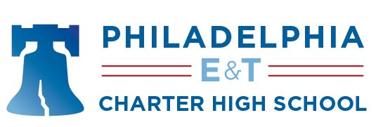

1709 Benjamin Franklin Parkway• Philadelphia, PA 19103• Phone: 267-514-1823Fax: 267-514-1834 • www.petchs.org ___________________________________________________________________________________________

September 23, 2022

Dear Parents/Guardians:

As a parent of a student attending a school that is receiving Federal Title I dollars, you have the
right to know the professional qualifications of the teacher(s) and instructional paraprofessional(s) who instruct your child. Federal law requires every Title I school district to comply and to provide you with the requested information in a timely manner.

All schools have on file a listing of faculty members and their professional qualifications.

If you would like to know the professional qualification information regarding your child’s teacher(s) or paraprofessional(s), please call the school to set up an appointment with the CEO or
the Head of Academics.

We look forward to a productive school year and thank you for your continued participation in
your child’s education.

Sincerely,

Erin Dougherty
Chief Executive Officer

